**2) Create a VPC network to communicate between 2 VM instance in different networks.**

Step 1 : Create two VPC networks in different regions , vpn-asiasouth1 and vpn-uscentral1

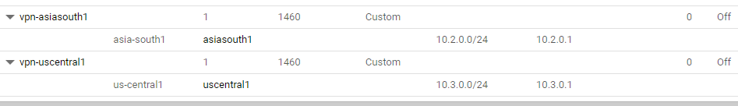

Step 2: Set firewall rules for both networks.

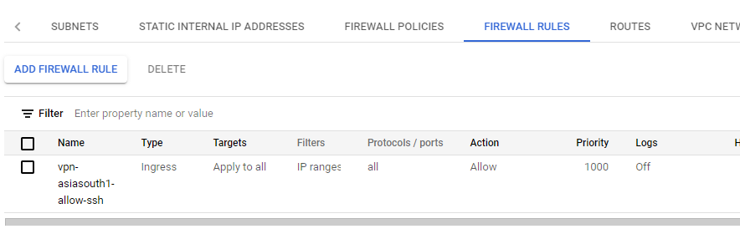

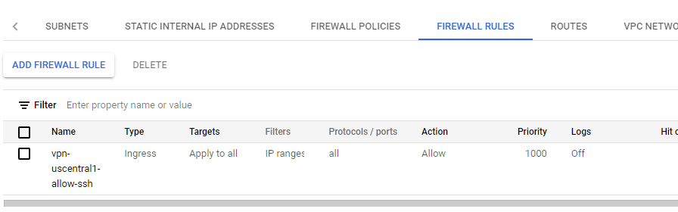

Step 3: Create VM instance for VPC network in asiasouth1 with Networking field as follows

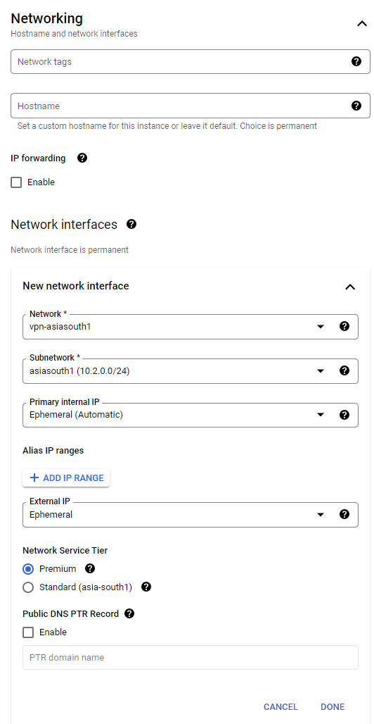

Step 4: Create VM instance for VPC network in uscentral1 with Networking field as follows

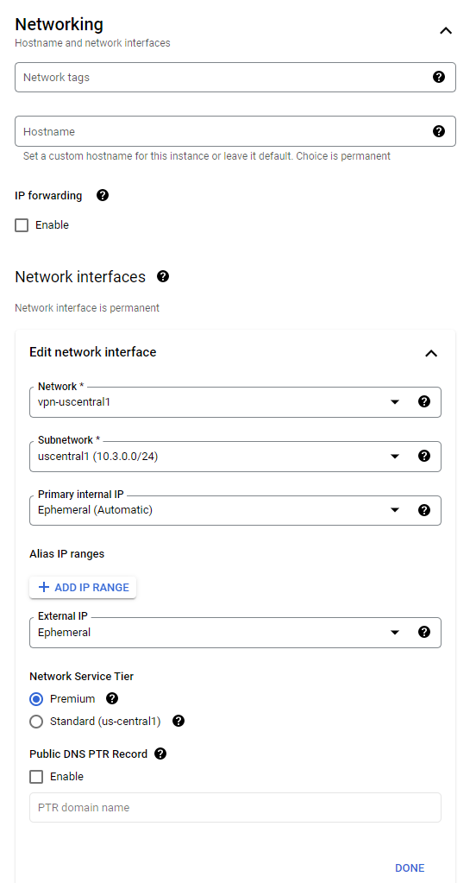

Step 5 : VM instance created for both networks

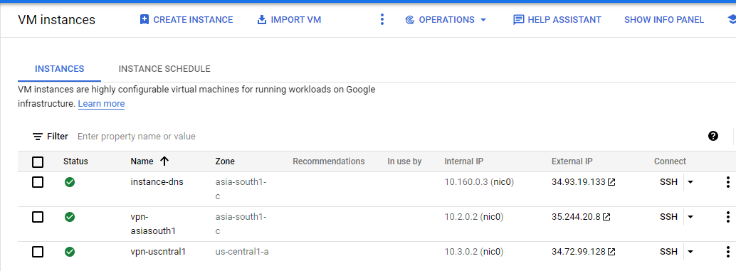

Step 6 : Try to establish connection between these two networks by clicking on SSH and ping.

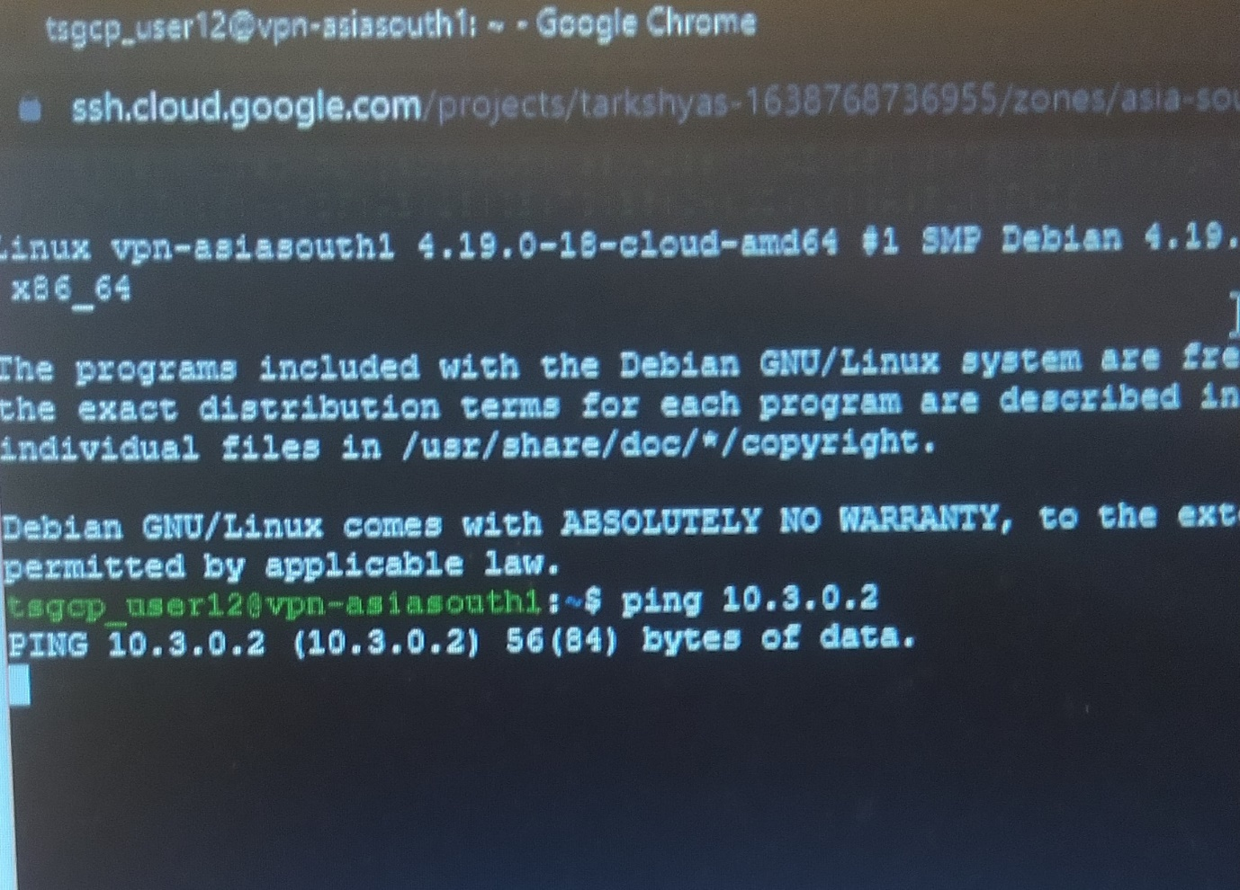

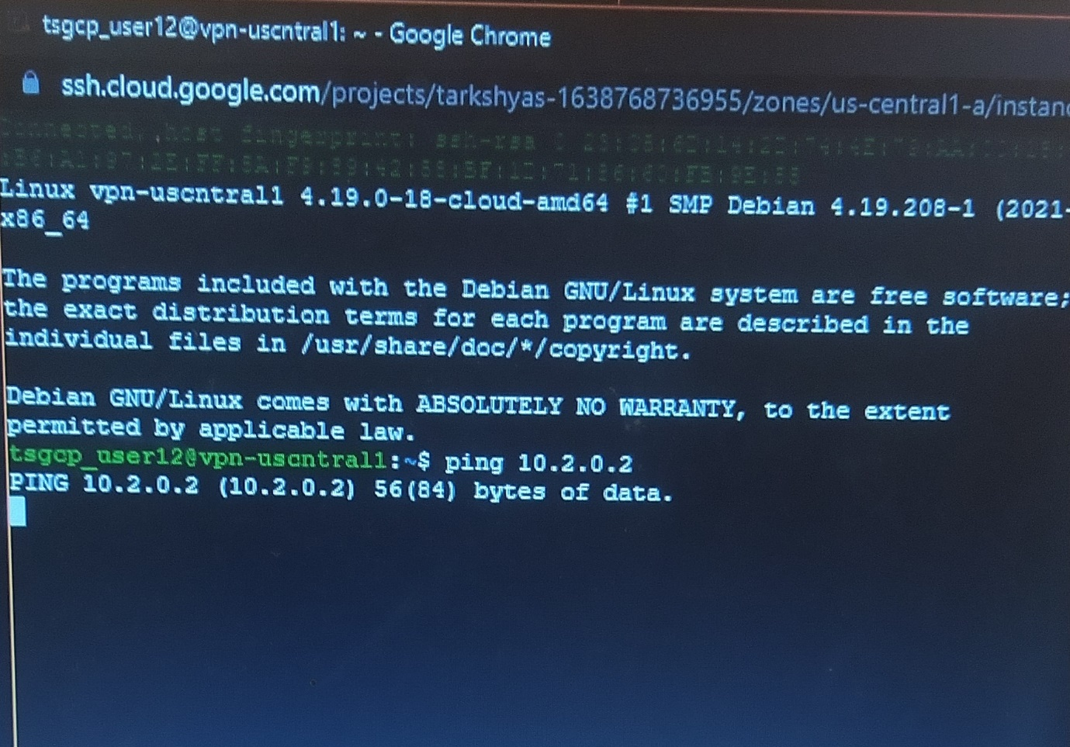

Here the connection fails. So inorder to establish connection, follow the below steps.

Step 7 : Reserve external IP address for both networks.

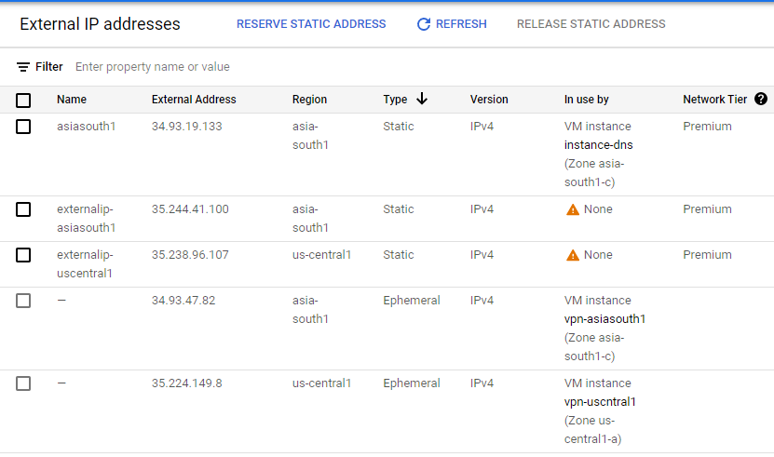

Step 8 : Open Hybrid Connectivity 🡪 VPN connection and create VPN for both networks

- Here the shared key must be same for both networks

- Remote peer IP address is the external IP address of other network

- Remote network IP range is the IP range of other network

***For vpn-asiasouth1 network :***

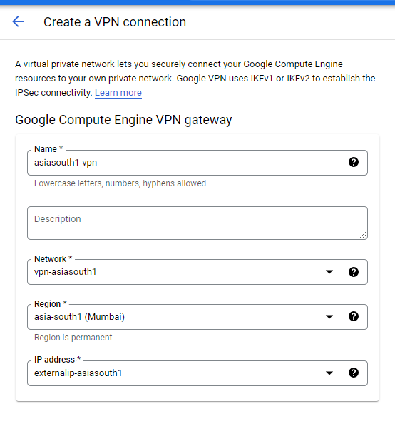

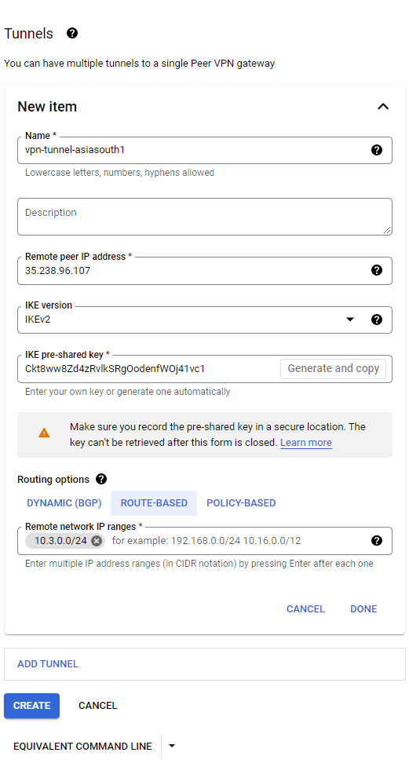

***For vpn-uscentral1 network :***

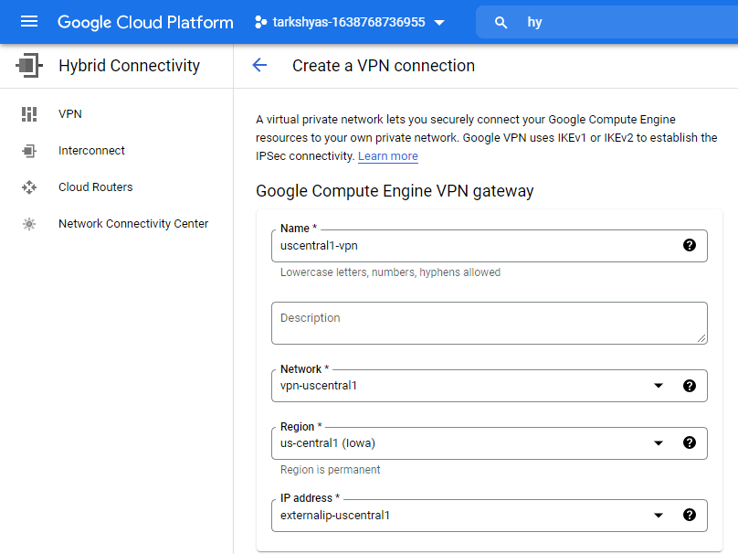

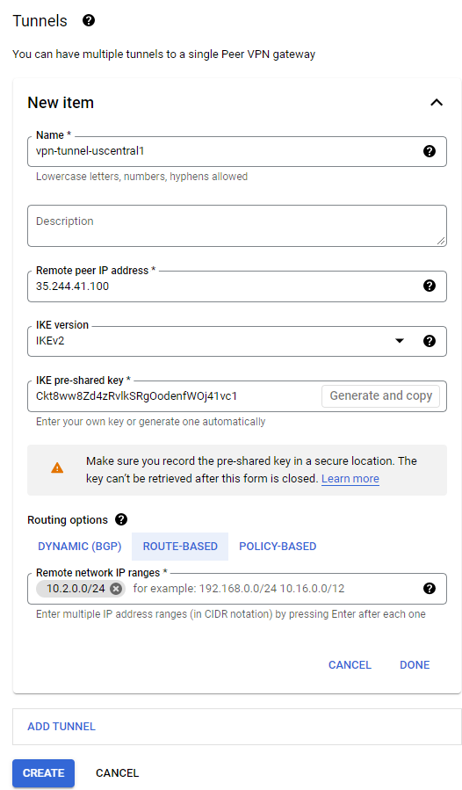

Step 9 : Created VPN connections

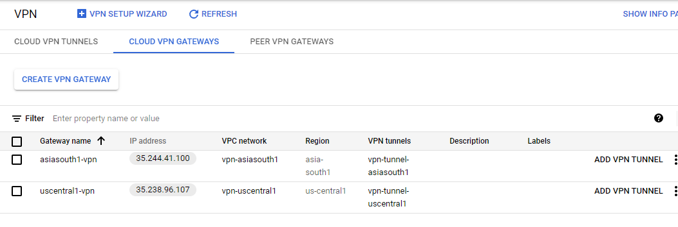

Step 10 : Now try to ping again.

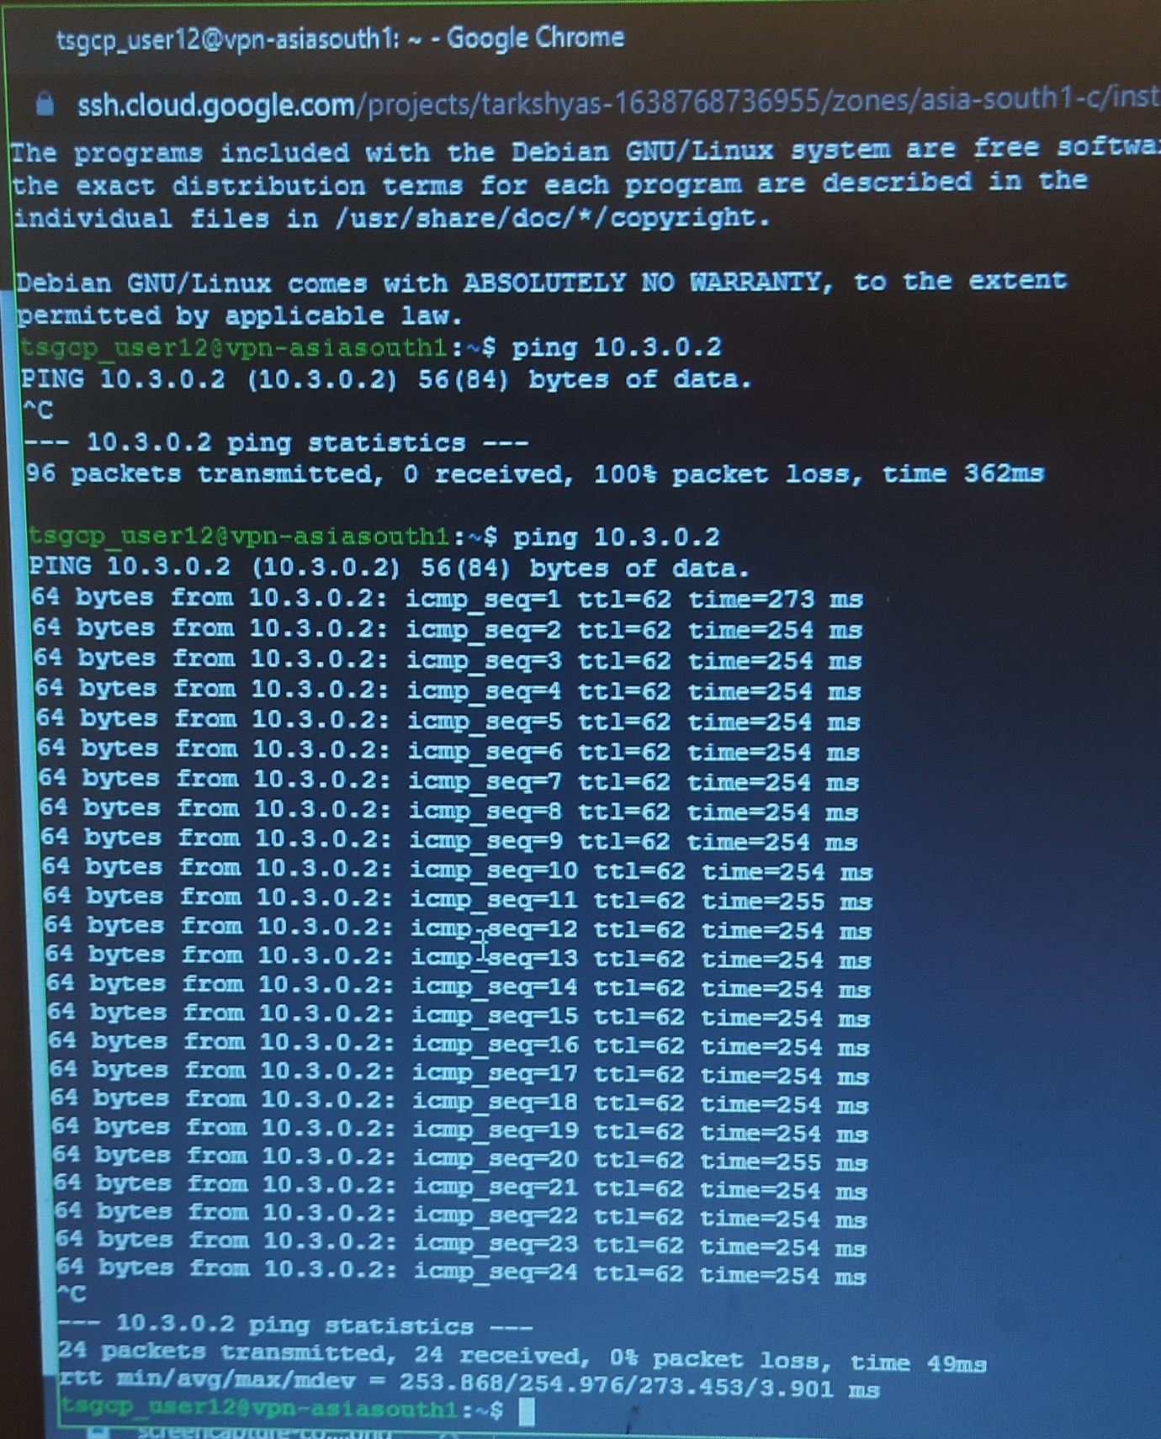

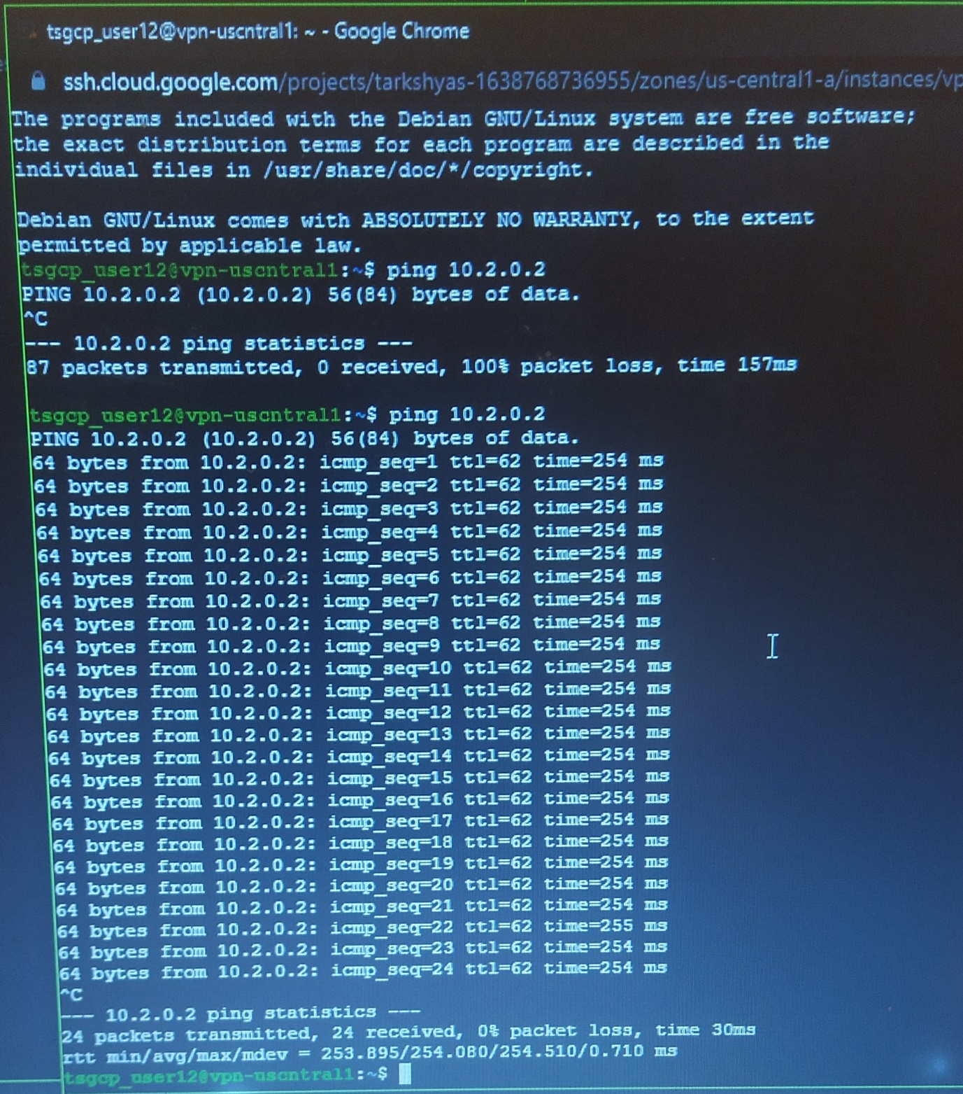

And thus the connection established successfully.